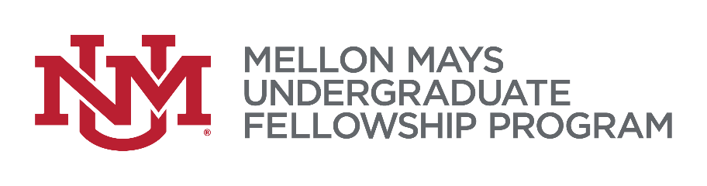
UNM Mellon Mays Undergraduate Fellowship (MMUF)
Research Fund Request Form

Each MMUF fellow is awarded up to $800 research fund. You may use the fund for materials you require for your research project (books, journals, software, workshop, office supplies, etc.) and also travel for conferences and graduate school visits. Please submit the request form to ksimmons.unm.edu. You must submit receipt(s) for this reimbursement.

Date:
Name:
UNM ID:
Email:
Mobile phone:
Description of item:
Purpose of the purchase:
Cost:

